 **Introduction to DevOps**

**BCS/BS 6A**

**Project Screenshots**

# Made By:

MUHAMMAD SHAYAN SHAHID (2212325)

**Directory structure showing a DevOps project with Terraform, Ansible, and app folders containing various configuration file**

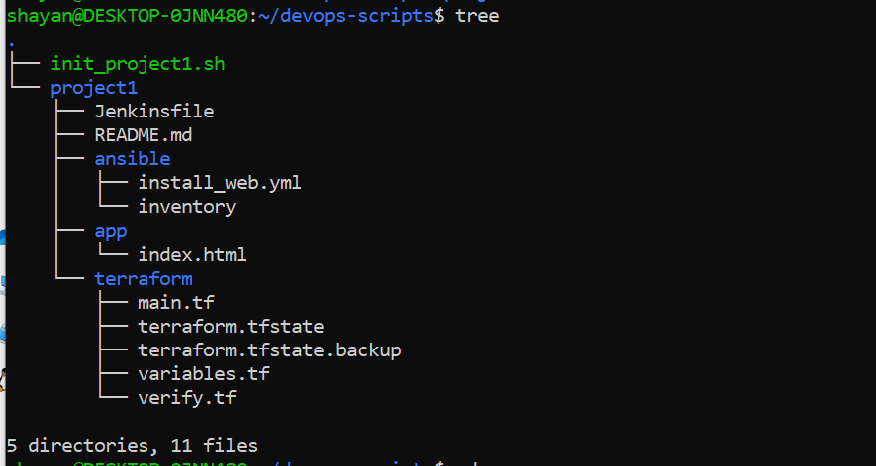

**Terraform initialization completed successfully, setting up the backend and provider plugins for Azure infrastructure deployment.**

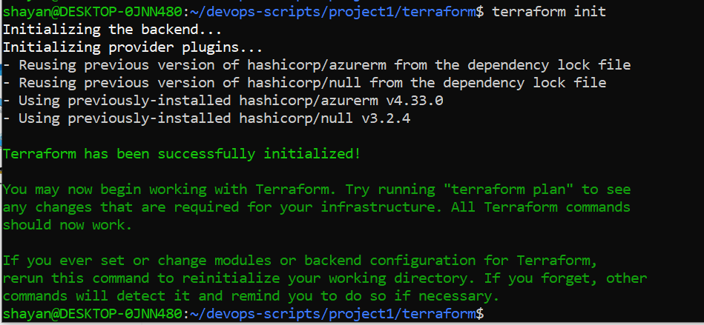

**Terraform apply executed with auto-approve, showing Azure resources being refreshed and confirming no changes needed with infrastructure outputs displayed.**

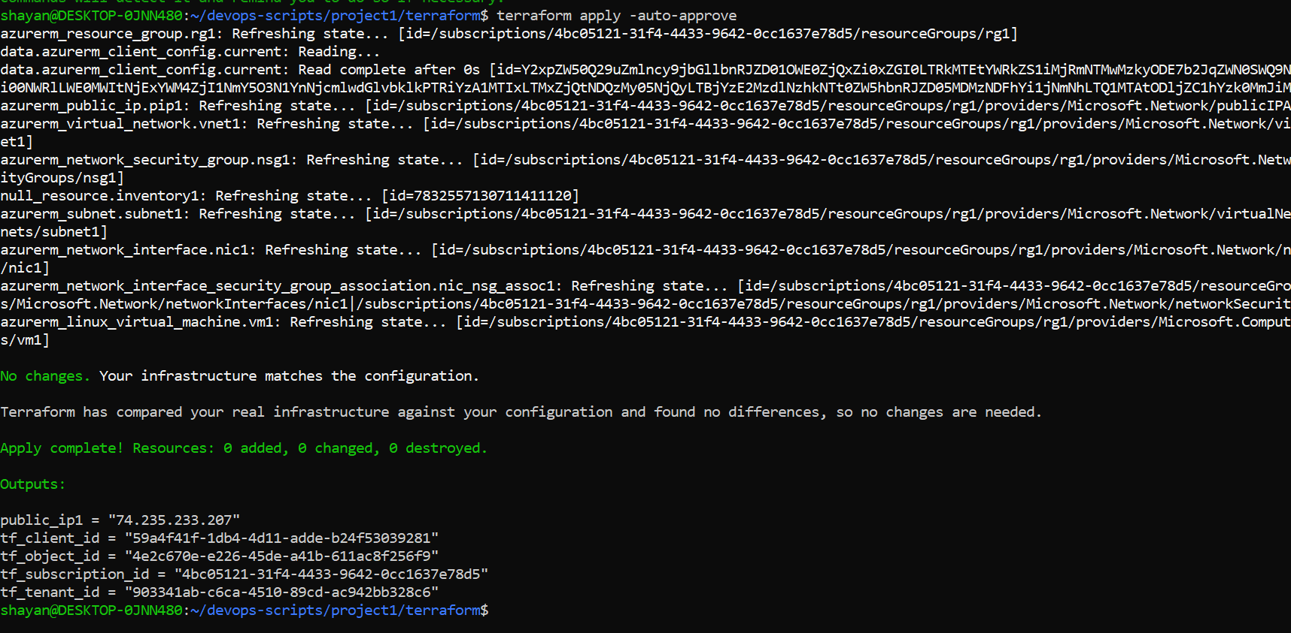

**Ansible playbook execution installing and configuring Apache web server on the provisioned Azure VM (IP: 74.235.233.207).**

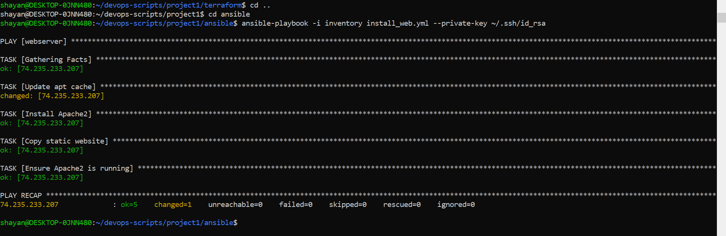

**Web browser displaying the deployed "DevOps Project: Automated Deployment" website explaining the project's Terraform, Ansible, and Jenkins integration.**

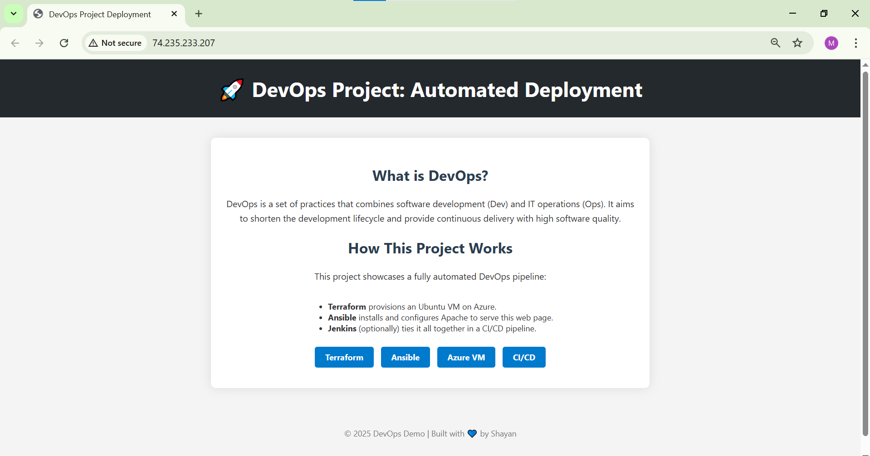

**Docker Desktop showing a Jenkins container running on ports 50000:50000 that was created 2 days ago.**

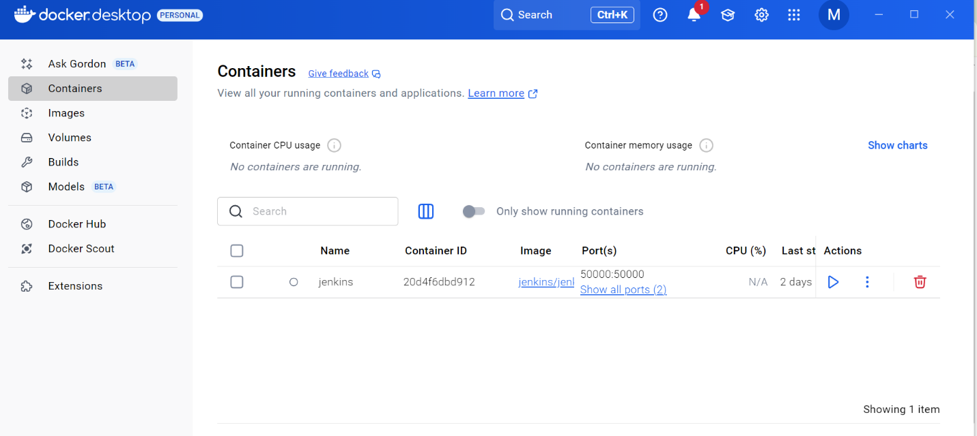

**Docker Desktop images tab displaying the Jenkins/Jenkins image (795.74 MB) that was pulled 18 days ago.**

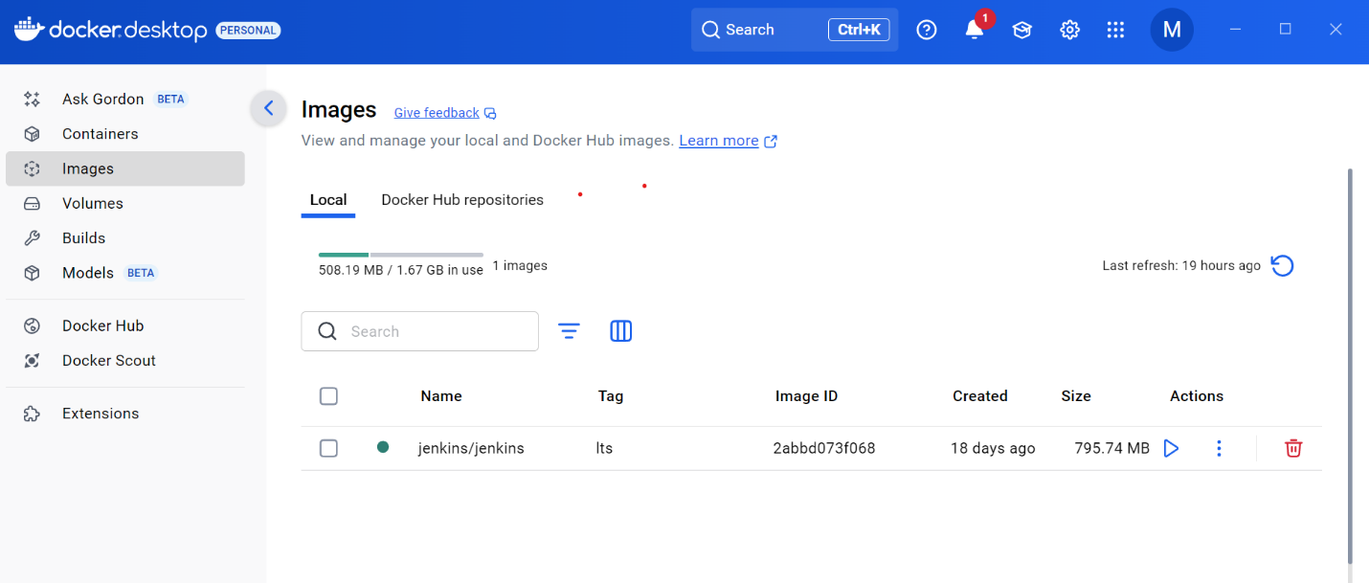

**Jenkins login page accessed via the container's IP address (172.30.16.1:8082) with username field populated.**

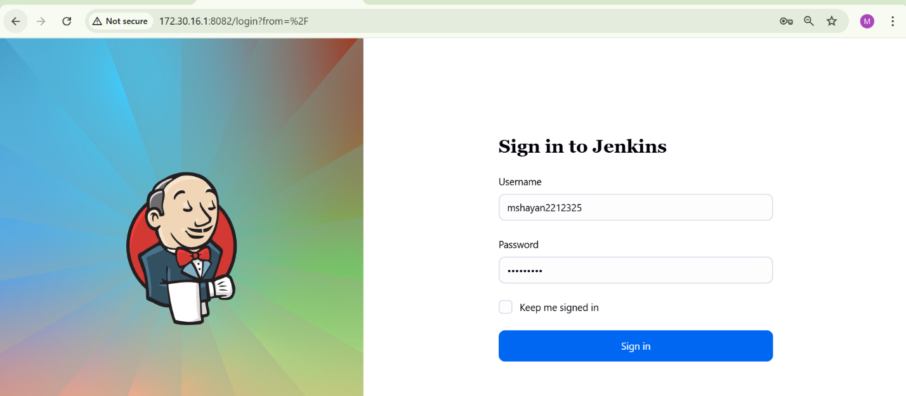

**Jenkins credentials management page showing configured Azure authentication credentials (SSH, Client ID, Secret, Tenant ID, Subscription ID).**

